**Snake River Basin Instream PIT Tag Detection Systems Prioritization – Implementation Plan**

**Version:** December 13, 2024

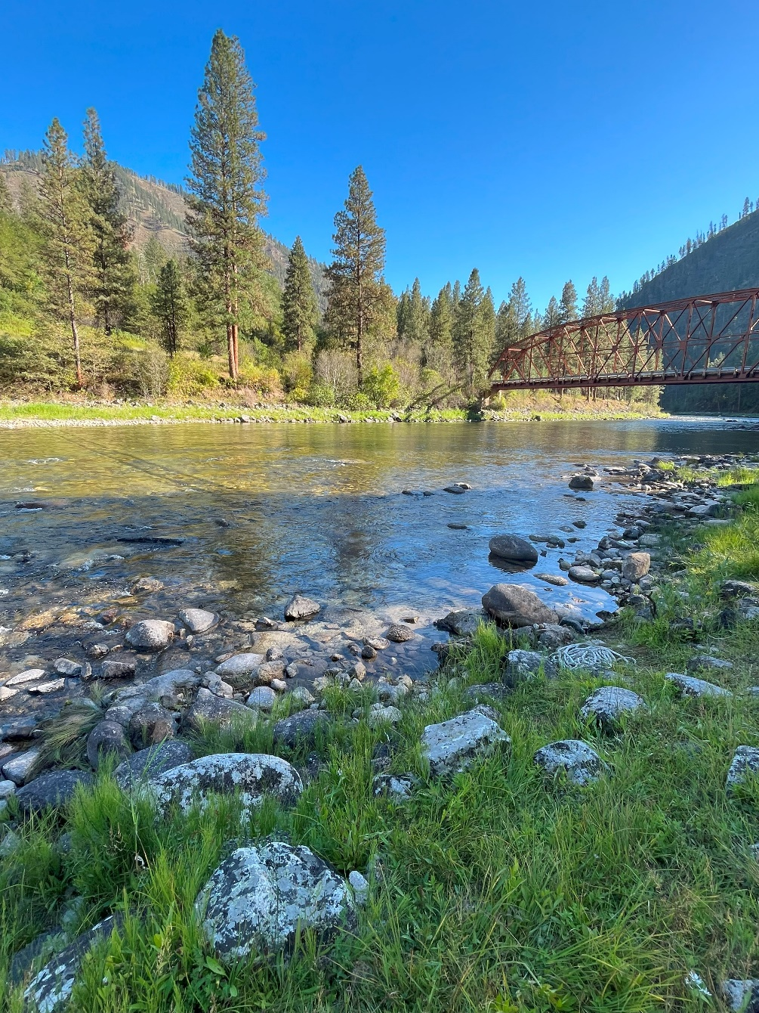

**Snake River Instream PIT-tag Detection Systems Prioritization Workgroup**

**Primary Contributors:** Michael W. Ackerman (NPT), Cameron Albee (NPT), Timothy Copeland (IDFG), Ethan Crawford (WDFW), Joseph W. Feldhaus (ODFW)

(this page intentionally left blank)

Table of Contents

BACKGROUND 3

Objectives 3

RECOMMENDATIONS 3

Continue Funding 3

Candidates to Transfer to IPTDS O&M Project 4

Decommission, Remove, or Transfer from IPTDS O&M Project 4

Proposed New Sites to Address Data Gaps 5

DISCUSSION 5

LITERATURE CITED 7

**Suggested Citation:**

Snake River Instream PIT-tag Detection Systems Prioritization Workgroup (SR IPTDS PW). 2025. Snake River Basin Instream PIT Tag Detection Systems Prioritization – Implementation Plan. BPA Project # 2010-057-00.

# BACKGROUND

Numerous Instream PIT Tag Detection Systems (IPTDS) have been installed throughout the Snake River basin to support various habitat action effectiveness and status and trends monitoring initiatives. The Integrated IPTDS Operations and Maintenance (O&M) project (BPA project number 2018-002-00) was created in 2018 to assume O&M responsibilities for a subset of these IPTDS. However, at its inception, it was not clear which IPTDS (i.e., which management, monitoring, or research objectives) should be prioritized and managed under the IPTDS O&M project. Since, it has been determined that the primary goal for prioritization and selection of IPTDS managed under the project is to provide the requisite adult status and trends information for summer-run steelhead (steelhead) and spring/summer run Chinook salmon (sp/sum Chinook salmon) populations of the Anadromous Salmonid Monitoring Strategy (ASMS; CBCAMW 2010). In 2024, a group of representatives from fisheries comanagers in the Snake River basin was convened to review current IPTDS in the basin and to provide recommendations to ensure that requisite IPTDS-based monitoring was in place to satisfy ASMS objectives (SR IPTDS PW 2024). This document is intended to summarize agreed upon recommendations and to provide a brief plan to implement those recommendations.

## Objectives

The Snake River basin IPTDS prioritization process resulted in recommendations that fall under the following four categories:

* Site recommended for continued funding under the IPTDS O&M project,
* Existing sites, currently funded under another project, recommended for funding under the IPTDS O&M project,
* Proposed new sites to address data gaps to be managed under the IPTDS O&M project, and
* Candidate sites for decommissioning, removal, or transfer from the IPTDS O&M project.

Here, we summarize IPTDS sites that fall under each of these categories and recommendations for each. Sites are recommendations are also displayed on the [Snake River IPTDS interactive web map](https://nptfisheries.shinyapps.io/sr-iptds/).

# RECOMMENDATIONS

## Continue Funding

Of the 32 IPTDS currently managed under the IPTDS O&M project, we recommend continued funding under the project for 23 of those (SR IPTDS PW 2024). For most, O&M can continue as-is. However, we provide the following recommendations for a subset of sites to provide improved and/or requisite monitoring.

**Table 1**. Recommendations for a subset of IPTDS sites in which funding should be continued.

| Site Code | Priority | Recommendation |
| --- | --- | --- |
| USE | Med | Long-term, consider upgrading to a IS1001 Master Controller to span the river and increase read range. |
| LLR | Low | Long-term, consider upgrading to a IS1001 Master Controller if current read ranges do not reach to the top of the water column during high flows. During upgrades, LLR could be considered for consolidation to a single-pass array. Detections at upstream sites allow for an estimate of a detection probability at LLR. |
| ESS | Med | Needs to remain a tandem site. The downstream array should be upgraded to a FS1001 MUX or IS1001 Master Controller, in time, to increase read range. |
| SC2 | High | SC2 should be moved to the lower boundary of the CRSFC-s population to improve monitoring for the SCUMA and CRSFC-s. SC2 could be installed as a tandem array if arrays could be adequately spaced to ensure independent detections, or preferably, SC4 should be considered for funding under the IPTDS O&M project long-term to ensure estimates of detection probability and abundance at SC2 (as a single array). |
| LC1 | Low | Long-term, consider upgrading to a IS1001 Master Controller to increase read range. |
| LC2 | Low | LC2 is currently difficult location for O&M. If it could reduce long-term costs, LC2 could be moved to an easier location upstream (but below core spawning areas), or alternately, LC1 could be converted to a tandem array if arrays could be spaced adequately for independent detections. Regardless, alternated configurations could be considered to reduce time and costs. |
| IR1 | Med | Upgrade to a IS1001 Master Controller to increase read range and improve site reliability, especially if and when IR2 is removed or decommissioned. |
| UGR | Low | Long-term, consider upgrading to a IS1001 Master Controller to increase read range. |
| WR1 | Med | Long-term, consider upgrading to a IS1001 Master Controller to increase read range. |

## Candidates to Transfer to IPTDS O&M Project

Nine sites currently funded under other projects are recommended to transfer to the IPTDS O&M project to provide continued requisite monitoring. If proponents for any of the sites do not desire transfer, adequate O&M and funding should be ensured, long-term.

**Table 2**. Recommendations and funding considerations for existing sites, currently funded under another project, recommended for funding under the IPTDS O&M project.

|  |  |  |  |
| --- | --- | --- | --- |
| Site Code | Priority | Recommendation | Funding Considerations |
| YFK | Low | Keep as a tandem array to ensure estimates of detection probability. Long-term, consider upgrading to a IS1001 Master Controller to increase read range. |  |
| PCA | Low | Keep as a tandem array to ensure estimates of detection probability. |  |
| SW1 | High | - |  |
| SW2 | High | Long-term, if desired, SW2 could be moved to the end of the Selway Road which would allow parsing of the SEMOO and SEUMA Chinook salmon populations from SEMEA, but if completed, would need to be a tandem array to facilitate estimates of detection probability and abundance. |  |
| SC4 | Low | SC4 would ensure an estimates of detection probability and abundance at SC2. |  |
| LAP | High | - |  |
| WR2 | High | - |  |
| MR1 | High | - |  |
| WEN | Med | Long-term, consider increasing distance between arrays to ensure independent detection nodes. |  |

## Decommission, Remove, or Transfer from IPTDS O&M Project

Nine sites currently funded under the IPTDS O&M are recommended for removal, decommissioning, or transfer to another project. These sites don’t necessarily need to be removed in the short-term. Sites that are not necessarily required for population monitoring could be rather “naturally phased out” i.e., sites that are currently operating reliably at low cost could remain instream until equipment aging or failure or environmental conditions (e.g., high flows, debris removing antennas and/or arrays) results in unreliable data for RM&E. Until then, detections from those sites might assist adult escapement monitoring and/or other RM&E objectives. Further, the opportunity should be provided for other projects to take over funding of those sites if the IPTDS supports their objectives. If and when removed or decommissioned, usable infrastructure or resources could be used elsewhere at other sites managed under the IPTDS O&M project.

**Table 3**. Recommendations and funding considerations for candidate sites for decommissioning, removal, and/or transfer from the IPTDS O&M project.

|  |  |  |  |
| --- | --- | --- | --- |
| Site Code | Priority | Recommendation | Funding Considerations |
| USI | Low | - |  |
| CAC | Low | - |  |
| BTL | Low | - |  |
| LLS | Low | - |  |
| BHC | Low | - |  |
| SFG | Low | Important site for in-season adult monitoring and juvenile survival monitoring. |  |
| BSC | Low | - |  |
| COC | Low | - |  |
| IR2 | Low | - |  |

## Proposed New Sites to Address Data Gaps

Up to four IPTDS sites are being proposed to address existing adult status and trends monitoring gaps. In each case, site feasibility will need to be evaluated, and depending, alternate sites or configurations should be considered. Proposed site locations will be discussed among relevant stakeholders in each case before any installation occurs.

**Table 4**. Recommendations for proposed sites to address adult population monitoring data gaps.

|  |  |  |  |
| --- | --- | --- | --- |
| Site Code | Priority | Arrays | Recommendation |
| USC | High | 1 | Little/no adult escapement monitoring currently occurs in the SREFS-s population. One IPTDS near the lower boundary of the SREFS-s population (downstream of Morgan Creek near Challis, ID) on the Salmon River should be considered. In addition, an IPTDS near the lower boundary of the SRUMA-s (near Clayton, ID) on the Salmon River would improve monitoring of the SRUMA-s, SREFS-s, and SRPAH-s populations. Depending on cost and feasibility, an IPTDS in the lower East Fork Salmon River could alternately be considered. Alternate configurations should be discussed among co-managers prior to action/installation to determine locations, but two new IPTDS would improve adult escapement monitoring for sp/sum Chinook salmon and steelhead in the upper Salmon subbasin. USI, at its current location, has been problematic and is not necessary for population status and trends monitoring and usable infrastructure could be used at proposed locations. |
| USP | High | 1 |
| CHA | High | 2 | The SRCHA-s and SRCHA populations are both “data” gaps for adult escapement monitoring. An IPTDS should be considered in these populations. Ideally, the site would be located near the lower end of Chamberlain Creek, the only major spawning area within both populations. Secondary options include upper Chamberlain Creek (near the airstrip), or in one of the five steelhead minor spawning areas (Sabe, Bargamin, Warren, Crooked, or Sheep creeks). Feasibility will need to be evaluated before any actions or installation occurs. |
| LSR | High | 2 | The SRLSR-s and SRLSR populations are both “data” gaps for adult escapement monitoring. An IPTDS should be considered in these populations. Proposed locations include the lower Little Salmon River, Slate Creek, or Whitebird Creek. |

# DISCUSSION

Each of the actions presented in this document are assigned a low, medium, or high priority. All sites designated as candidates for decommissioning, removal, or transfer from the IPTDS O&M project are assigned “low” priority. These sites could be “naturally phased out” and/or time should be allowed for project proponents to take over funding for those sites. Alternately, all proposed new sites are assigned a “high” priority to address current adult status and trends monitoring “data gaps”. In general, the aim could be for high priority actions to occur in the next 1-2 years whereas low priority actions could take place in 3-5 years. Regardless, we will need to evaluate field work plans annually to consider the actions that take place each year and re-evaluate depending on funding, resources, available staff, etc. For example, specialized staff may only be available to replace existing or install new sites for 1-3 sites annually. As such, annual work plans can be flexible to consider actions that can be facilitated each year.

**Table 5**. General guidelines for timelines to address recommended actions following the Snake River basin IPTDS prioritization process (SR IPTDS PW 2024).

|  |  |
| --- | --- |
| Priority | General Guidelines for Years of Action |
| High | 2025 – 2026 |
| Medium | 2026 - 2028 |
| Low | 2027 - 2029 |

The recommendations provided from the Snake River IPTDS Prioritization process (SR IPTDS PW) are estimated to increase overall, annual infrastructure and O&M costs by approximately $65,500, which is 23% greater than current estimated costs, when considered altogether. These estimates do not include staffing, travel and per diem, vehicles, and additional costs not directly related to up-front infrastructure or O&M to IPTDS sites but provide a “ballpark” in changes to O&M costs for the IPTDS O&M project. Potential changes in costs, including how it affects each project proponent involved, will need to be discussed and addressed prior to contracting decisions and recommended actions are implemented.

A primary goal of the Integrated IPTDS O&M project is to provide the necessary O&M for IPTDS deemed necessary for requisite adult status and trends monitoring throughout the Snake River basin. However, the project could adopt IPTDS that support other RM&E monitoring or research objectives as the project could provide specialized staff and resources to perform O&M efficiently and at reduced costs. However, the costs for any site considered for adoption would need to be reviewed and appropriate funding should be provided to the IPTDS O&M project to ensure that adequate staff and resources are available to perform necessary O&M for those sites. Finally, discussions would need to occur among co-managers to decide additional RM&E objectives that could/should be supported by the project.

# LITERATURE CITED

Columbia Basin Coordinated Anadromous Monitoring Workshop (CBCAMW). 2010. Anadromous Salmonid Monitoring Strategy Viable Salmonid Population Criteria and Subset of Tributary Habitat and Hatchery Effectiveness, Version 30062010. 59 pp.

Snake River Instream PIT-tag Detection Systems Prioritization Workgroup (SR IPTDS PW). 2024. Prioritization of Instream PIT Tag Detection Systems for Requisite Monitoring of Steelhead and Spring-Summer Chinook Salmon Adult Abundance and Life History, Snake River Basin. BPA Project # 2010-057-00.